Capstone data analytics and data science project:

Course Scraping data
from bs4 import BeautifulSoup
import requests
import pandas as pd

define scraping function
def auto_Scrapper_Class(html_tag,course_case,tag_class, div_class=None):
"""
The function auto_Scrapper_Class is used to get three parameters that is the tag,what to scrap and get the content scrapped and class it belongs.
"""
for i in range(1,50): # adjust as needed, according to current coursera website, there are 83 pages for all courses
url = "https://www.coursera.org/courses?page=" +str(i)

#Use below url to gain more customization on the result with different query
#url = "https://www.coursera.org/search?query=data%20science&page=" +str(i)

page = requests.get(url)
soup = BeautifulSoup(page.content, 'html.parser')

if div_class:
elements = soup.find_all('div', class_ = div_class)

if (len(elements)) != 12:
for j in range(0,12): # There are 12 courses per page
course_case.append(None)
continue
for name in elements:
x = name.get_text()
if x:
course_case.append(x)
else:
course_case.append(None)

else:
element = soup.find_all(html_tag, class_ = tag_class)
if (len(element)) != 12:
for j in range(0,12):
course_case.append(None)
continue

for name in element:
x = name.get_text()
if x:
course_case.append(x)
else:
course_case.append("")
course_title = []
course_organization = []
course_Certificate_type = []
course_rating = []
course_difficulty = []
course_review_counts = []
course_skills = []
#scrap the course title
auto_Scrapper_Class('h3',course_title, tag_class='cds-119 cds-CommonCard-title css-e7lgfl cds-121')
#scrap the other information as per coursera's website html
auto_Scrapper_Class('p',course_organization,'cds-119 cds-ProductCard-partnerNames css-dmxkm1 cds-121')
#auto_Scrapper_Class('div',course_Certificate_type,'_jen3vs _1d8rgfy3')
auto_Scrapper_Class('p',course_rating,'cds-119 css-11uuo4b cds-121')
auto_Scrapper_Class('p',course_difficulty,'cds-119 cds-Typography-base css-dmxkm1 cds-121', 'cds-CommonCard-metadata')
auto_Scrapper_Class('p',course_review_counts,'cds-119 cds-Typography-base css-dmxkm1 cds-121', 'product-reviews css-pn23ng')
auto_Scrapper_Class('p',course_skills,'cds-119 cds-Typography-base css-dmxkm1 cds-121', 'cds-CommonCard-bodyContent' )

#df.to_csv("coursera_course_dataset.csv")
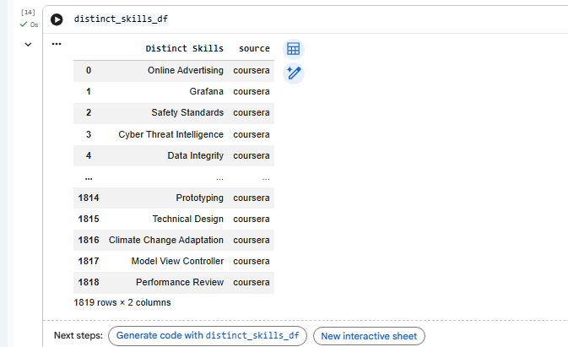
skills_column = df['Skills']

skills_column = [str(skill) if skill is not None else '' for skill in skills_column]

# Concatenate all skills into a single string
all_skills_text = ', '.join(skills_column)

# Split the string into a list of skills
all_skills_list = [skill.strip() for skill in all_skills_text.split(',')]

# Get unique skills
distinct_skills = list(set(all_skills_list))

distinct_skills_df = pd.DataFrame({'Distinct Skills': distinct_skills,'source':"coursera"})
len(distinct_skills)
skills_column = df['Skills']

skills_column = [str(skill) if skill is not None else '' for skill in skills_column]

# Concatenate all skills into a single string
all_skills_text = ', '.join(skills_column)

# Split the string into a list of skills
all_skills_list = [skill.strip() for skill in all_skills_text.split(',')]

# Get unique skills
distinct_skills = list(set(all_skills_list))

distinct_skills_df = pd.DataFrame({'Distinct Skills': distinct_skills,'source':"coursera"})
len(distinct_skills)

list_lengths = [
len(course_title),
len(course_organization),
len(course_skills),
len(course_rating),
len(course_review_counts),
len(course_difficulty)
]

min_length = min(list_lengths)

# Truncate all lists to the minimum length
course_title = course_title[:min_length]
course_organization = course_organization[:min_length]
course_skills = course_skills[:min_length]
course_rating = course_rating[:min_length]
course_review_counts = course_review_counts[:min_length]
course_difficulty = course_difficulty[:min_length]

data = {
'Title': course_title,
'Organization': course_organization,
'Skills': course_skills,
'Ratings':course_rating,
'Review counts':course_review_counts,
'Metadata': course_difficulty
}
df = pd.DataFrame(data)
df['Skills'] = df['Skills'].str.replace("Skills you'll gain:", '', regex=False)
df
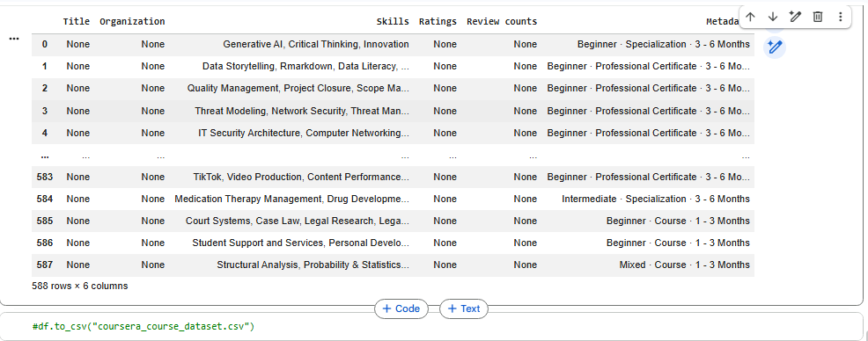
df.to_csv("coursera_course_dataset.csv", index=False)
from google.colab import files
files.download("coursera_course_dataset.csv")

